SIMATS ENGINEERING
ASSESSMENT TOOL 1

Experiments

COURSE NAME: Computer Networks COURSE CODE: CSA07

COURSE OUTCOME COVERED

CO3: Analyze the performance of core network protocols such as TCP, UDP, HTTP, and DNS under varying conditions
Assessment Tool Weightage: 40%
SOFTWARE: CISCO PACKET TRACER, WIRESHARK

EXPERIMENTS

QUESTIONS:4 Total Marks:40

1.Construct a local area network with multiple hosts connected through a switch in Cisco Packet Tracer. Clear the ARP cache on one of the hosts and initiate communication with another host using the ping command. Capture the communication in Wireshark and identify the ARP Request and ARP Reply packets. Analyze the sender and target MAC/IP addresses and explain how the Address Resolution Protocol resolves logical IP addresses into physical MAC addresses before data transmission.

Aim:
To construct a Local Area Network (LAN) with multiple hosts connected through a switch using Cisco Packet Tracer, clear the ARP cache of a host, and use the ping command to initiate communication. The ARP Request and ARP Reply packets are captured and analyzed using Wireshark to understand how ARP resolves an IP address into the corresponding MAC address before data transmission.
Procedure:
- Open Cisco Packet Tracer, add one switch and three PCs, and connect all PCs to the switch using Copper Straight-Through cables.
- Configure the IP addresses of the PCs in the same network, for example 192.168.1.10, 192.168.1.20, and 192.168.1.30 with subnet mask 255.255.255.0.
- Open the Command Prompt of one PC and check its ARP table using the arp -a command. Clear the ARP cache using the appropriate ARP command.
- Start Wireshark packet capture and initiate communication from the selected PC to another PC using the ping command.
- Apply the Wireshark filter arp and identify the ARP Request packet, where the sender broadcasts a request to find the MAC address associated with the target IP address.
- Identify the ARP Reply packet, where the destination PC responds with its MAC address. Note the sender and target MAC/IP addresses in both packets.
- Observe the subsequent ICMP Echo Request and Echo Reply packets to verify that communication between the two hosts is successful.
- Analyze the captured packets and explain how ARP maps the logical IP address to the physical MAC address before the actual data transmission takes place.

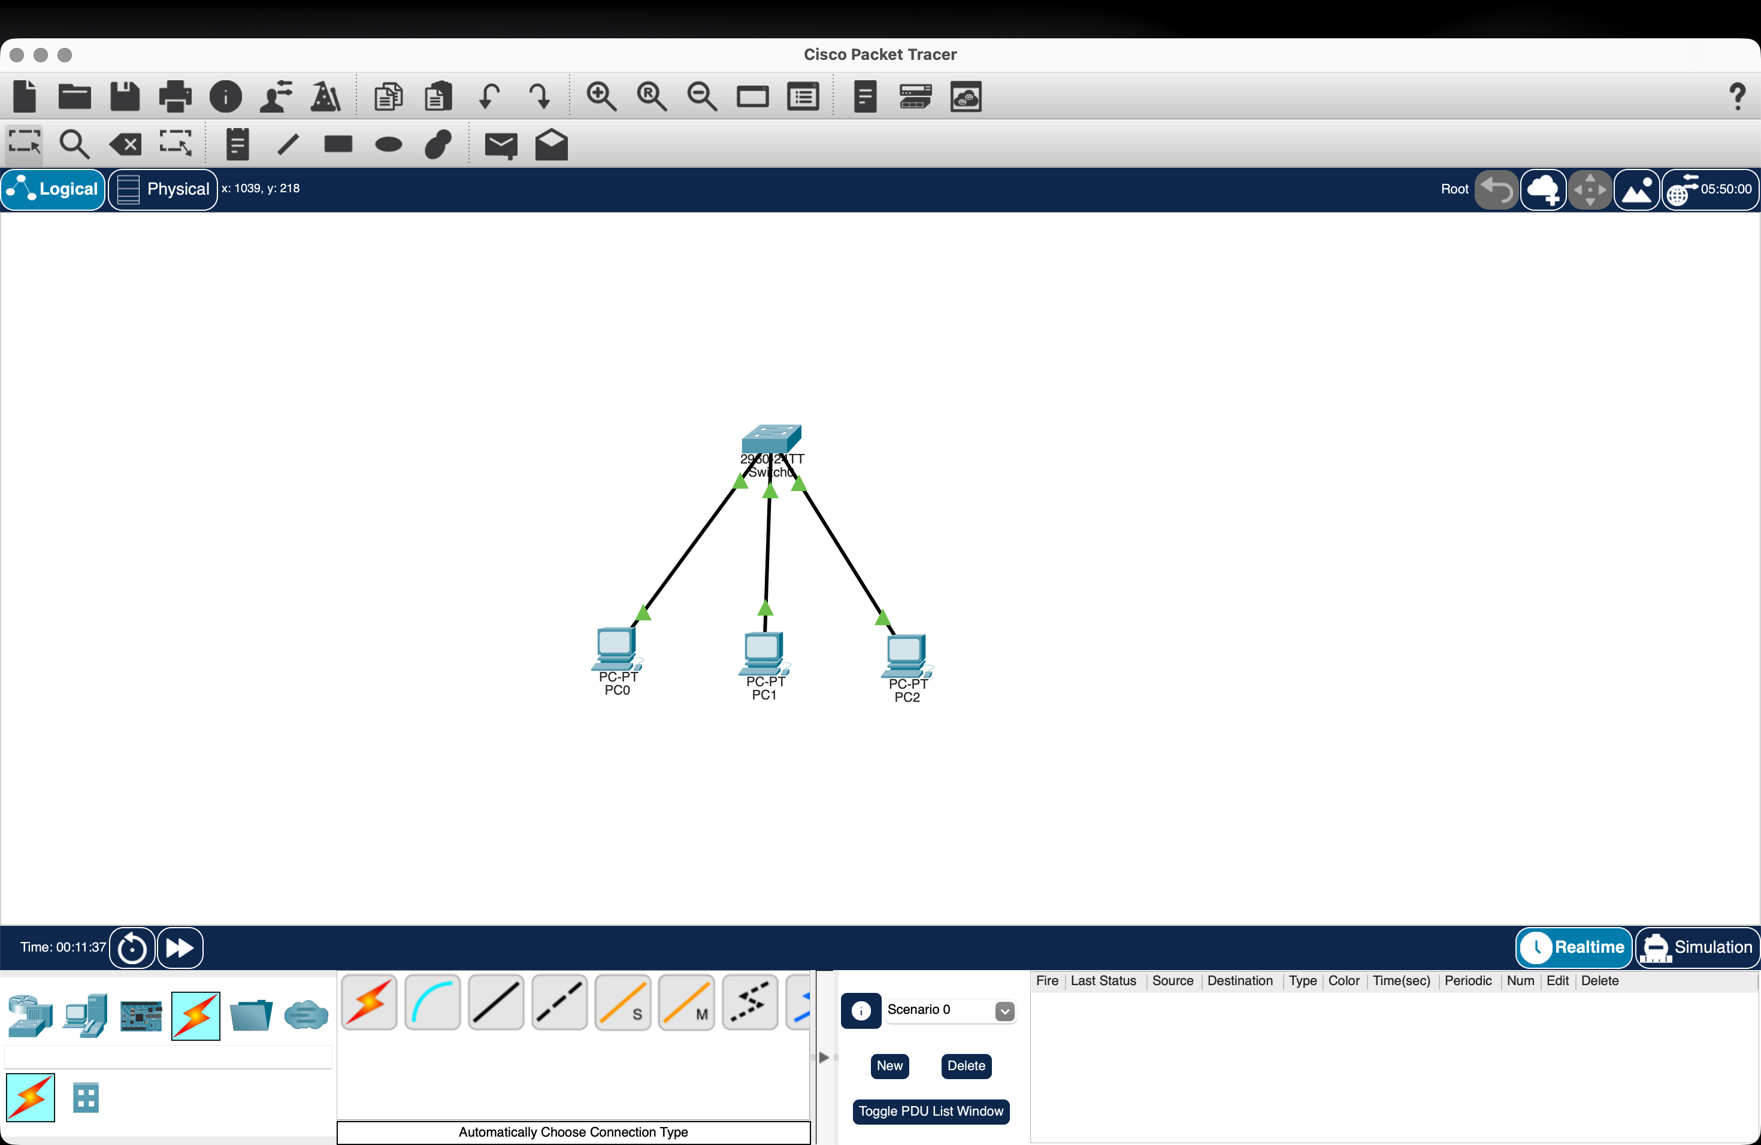
Implementation-1:
Fig1:LAN Topology with Multiple Hosts Connected Through a Switch

Explanation:
In Cisco Packet Tracer, three PCs are connected to a single switch using Ethernet cables to form a Local Area Network (LAN). Each PC is assigned a unique IP address within the same network, such as 192.168.1.1, 192.168.1.2, and 192.168.1.3, with the subnet mask 255.255.255.0. The switch provides communication between the connected hosts, allowing them to exchange data within the LAN. Connectivity is verified by using the ping command between the PCs.
S. No. | Device | IP Address | Subnet Mask | Purpose
1 | PC0 | 192.168.1.1 | 255.255.255.0 | Source host
2 | PC1 | 192.168.1.2 | 255.255.255.0 | Destination host
3 | PC2 | 192.168.1.3 | 255.255.255.0 | Additional LAN host
4 | Switch | — | — | Connects all hosts

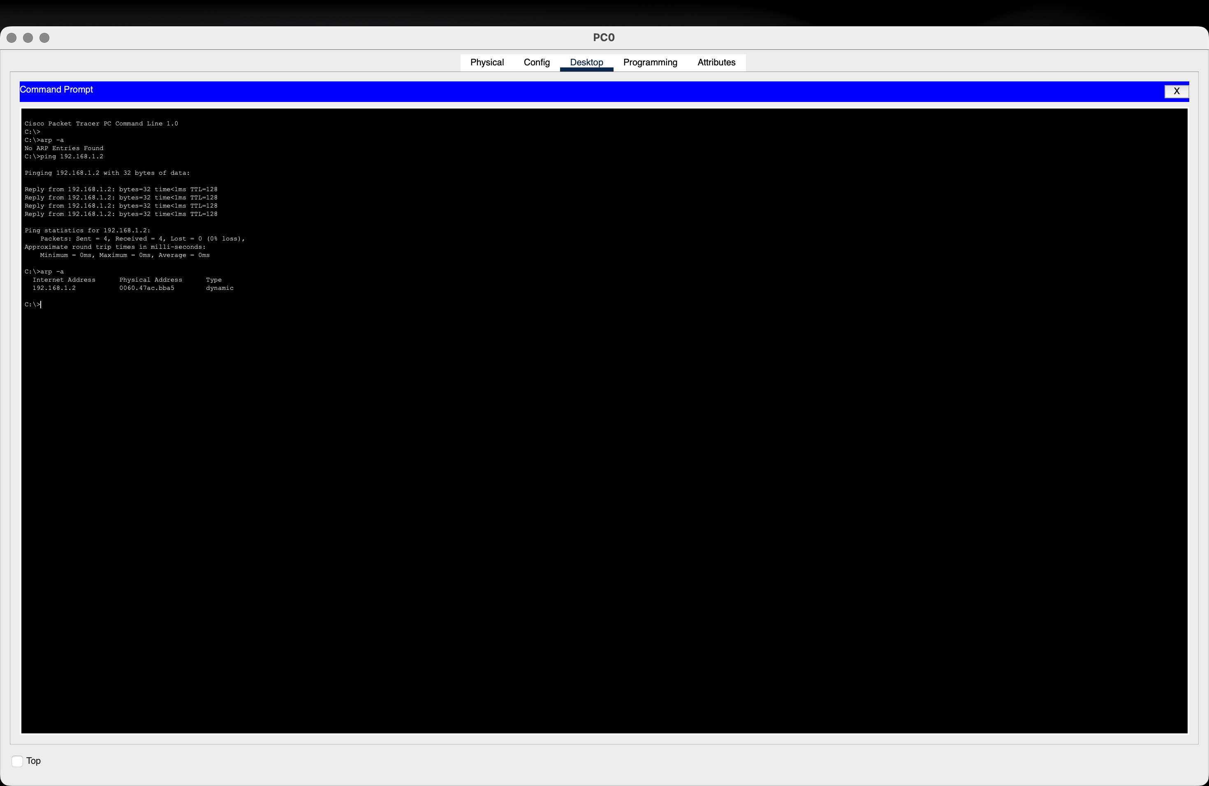
Implementation-2:

Fig2:ARPCache Verification and Ping Communication
Explanation:
The figure shows the PC0 Command Prompt in Cisco Packet Tracer. Initially, the ARP table is empty, as indicated by “No ARP Entries Found.” PC0 then sends a ping to PC1 at IP address 192.168.1.2. The four successful replies confirm that communication between the two hosts is working correctly. After the ping, the arp -a command displays the dynamically learned MAC address corresponding to 192.168.1.2. This demonstrates that ARP successfully resolved the destination IP address into its MAC address for communication.
Parameter | Result
Source IP | 192.168.1.1
Destination IP | 192.168.1.2
Ping Packets Sent | 4
Ping Packets Received | 4
Packet Loss | 0%
ARP Status Before Ping | No ARP Entries Found
ARP Status After Ping | MAC address learned dynamically
Communication Status | Successful

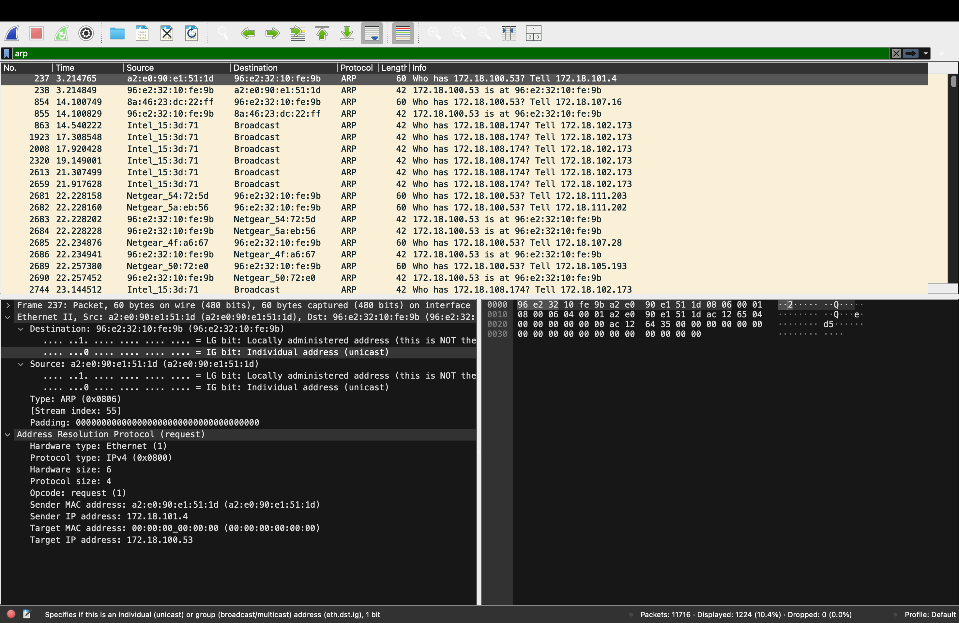
Implementation-3:
Fig3: ARP Request Packet Captured in Wireshark
Explanation:
The ARP Request is sent by the device with IP address 172.18.101.4. Since it does not know the MAC address corresponding to 172.18.100.53, it sends an ARP Request asking which device owns that IP address. The target MAC is shown as 00:00:00:00:00:00 because the MAC address is not yet known.

Field | Value
Packet Type | ARP Request
Sender MAC | a2:e0:90:e1:51:1d
Sender IP | 172.18.101.4
Target MAC | 00:00:00:00:00:00
Target IP | 172.18.100.53

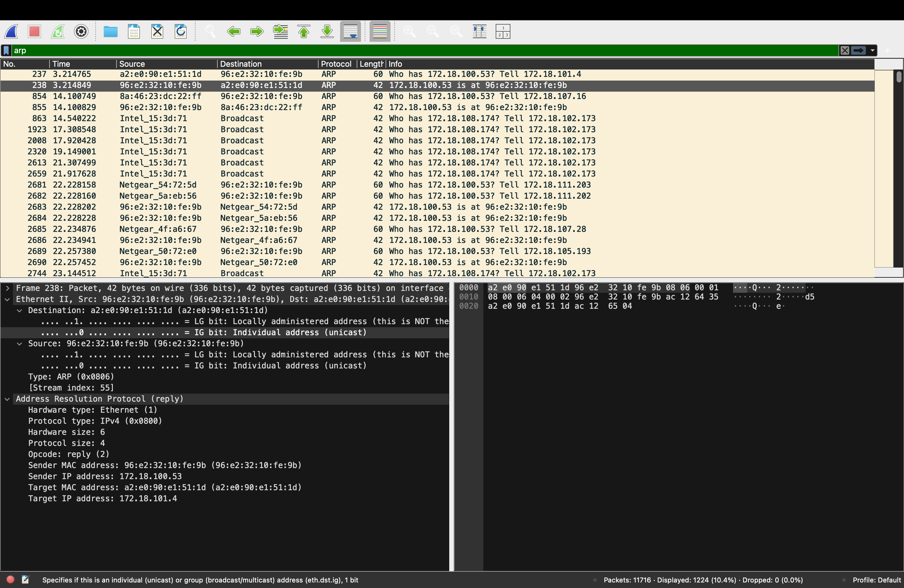
Implementation-4:

Figure 4: ARP Reply Packet Captured in Wireshark
Explanation
The ARP Reply is sent by the device with IP address 172.18.100.53 in response to the ARP Request. It provides its MAC address 96:e2:32:10:fe:9b to the device with IP address 172.18.101.4. This allows the requesting device to associate the destination IP address with its physical MAC address and proceed with data transmission.
Field | ARP Reply
Packet No. | 238
Sender MAC | 96:e2:32:10:fe:9b
Sender IP | 172.18.100.53
Target MAC | a2:e0:90:e1:51:1d
Target IP | 172.18.101.4

Analysis and Explanation of ARP:
From the captured Wireshark packets, the ARP Request shows that the sender IP address is 172.18.101.4 with MAC address a2:e0:90:e1:51:1d. The target IP address is 172.18.100.53, while the target MAC address is initially unknown (00:00:00:00:00:00).
The ARP Reply is sent by 172.18.100.53, whose MAC address is 96:e2:32:10:fe:9b. It provides this MAC address to the sender 172.18.101.4.

How ARP works:
- The sender knows the destination IP address, but not its MAC address.
- It broadcasts an ARP Request asking, “Who has 172.18.100.53?”
- The device having that IP address responds with an ARP Reply containing its MAC address.
- The sender stores the IP-to-MAC mapping in its ARP cache.
- The sender can now use the destination MAC address to deliver the Ethernet frame.
- Therefore, ARP resolves the logical IP address into the physical MAC address required for data transmission on the local network.

2.Develop a simple network consisting of two PCs connected through a router in Cisco Packet Tracer. Configure the required IP addresses and test connectivity using the ping command. Capture the ICMP traffic using Wireshark and identify the Echo Request and Echo Reply messages. Examine important ICMP fields such as Type, Code, Identifier, and Sequence Number, and calculate the Round Trip Time (RTT). Discuss how ICMP assists in network troubleshooting and connectivity verification.

Aim:
To develop a simple network consisting of two PCs connected through a router in Cisco Packet Tracer, configure the required IP addresses, and verify connectivity using the ping command. The ICMP Echo Request and Echo Reply packets are captured and analyzed in Wireshark by examining fields such as Type, Code, Identifier, Sequence Number, and Round Trip Time (RTT).
Procedure:
- Create a topology with two PCs and one router in Cisco Packet Tracer and connect them using Ethernet cables.
- Configure IP addresses, subnet masks, and default gateways for both PCs and the router interfaces.
- Use the ping command from one PC to the other to verify network connectivity.
- Start Wireshark and capture the ICMP traffic generated by the ping operation.
- Apply the icmp filter in Wireshark and identify the Echo Request (Type 8) and Echo Reply (Type 0) packets.
- Examine the Type, Code, Identifier, Sequence Number, and packet timestamps to determine the RTT.
- Analyze the results and explain how ICMP helps in connectivity verification and network troubleshooting.

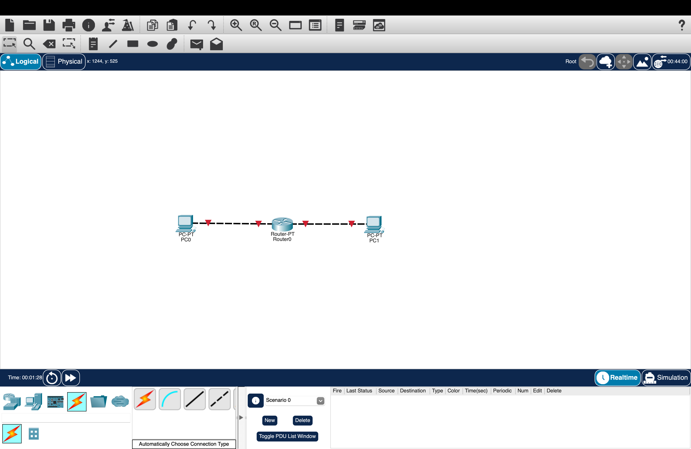
Implementation-1:
Fig1:Network Topology with Two PCs Connected Through a Router

Explanation:
The figure shows a simple network topology created in Cisco Packet Tracer, consisting of two PCs (PC0 and PC1) connected through a router (Router0). PC0 is connected to one interface of the router, while PC1 is connected to another interface. The router acts as an intermediary device that forwards data packets between the two PCs and their respective networks. The red link indicators show that the interfaces are currently down, so the router interfaces need to be configured and enabled before communication can take place.
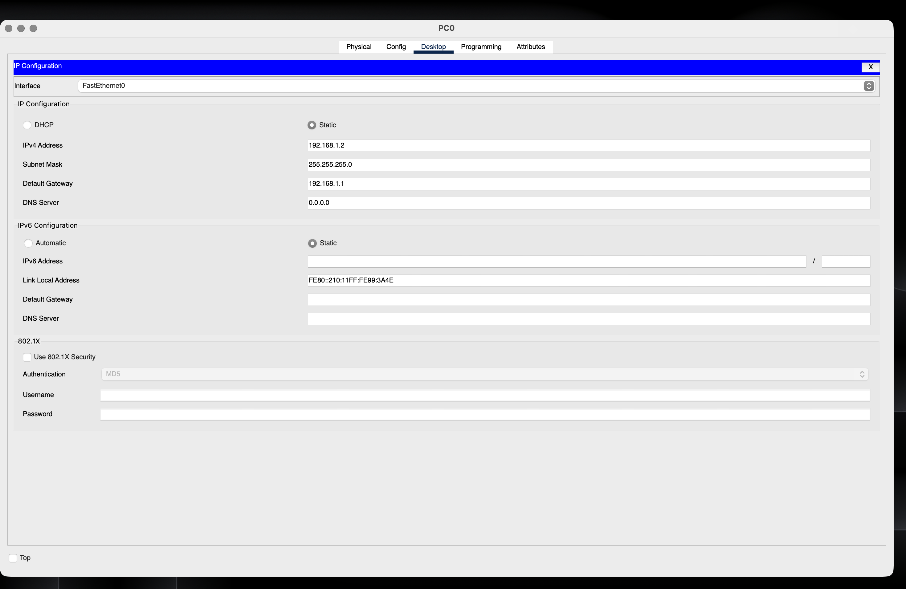
Implementation-2:

Fig2:IPAddress Configuration of PC0
Explanation:
The figure shows the IPv4 configuration of PC0 in Cisco Packet Tracer. A static IP address of 192.168.1.2 is assigned with the subnet mask 255.255.255.0. The default gateway is configured as 192.168.1.1, which is the router interface connected to PC0. This configuration allows PC0 to communicate with the router and access devices on other networks through the router.
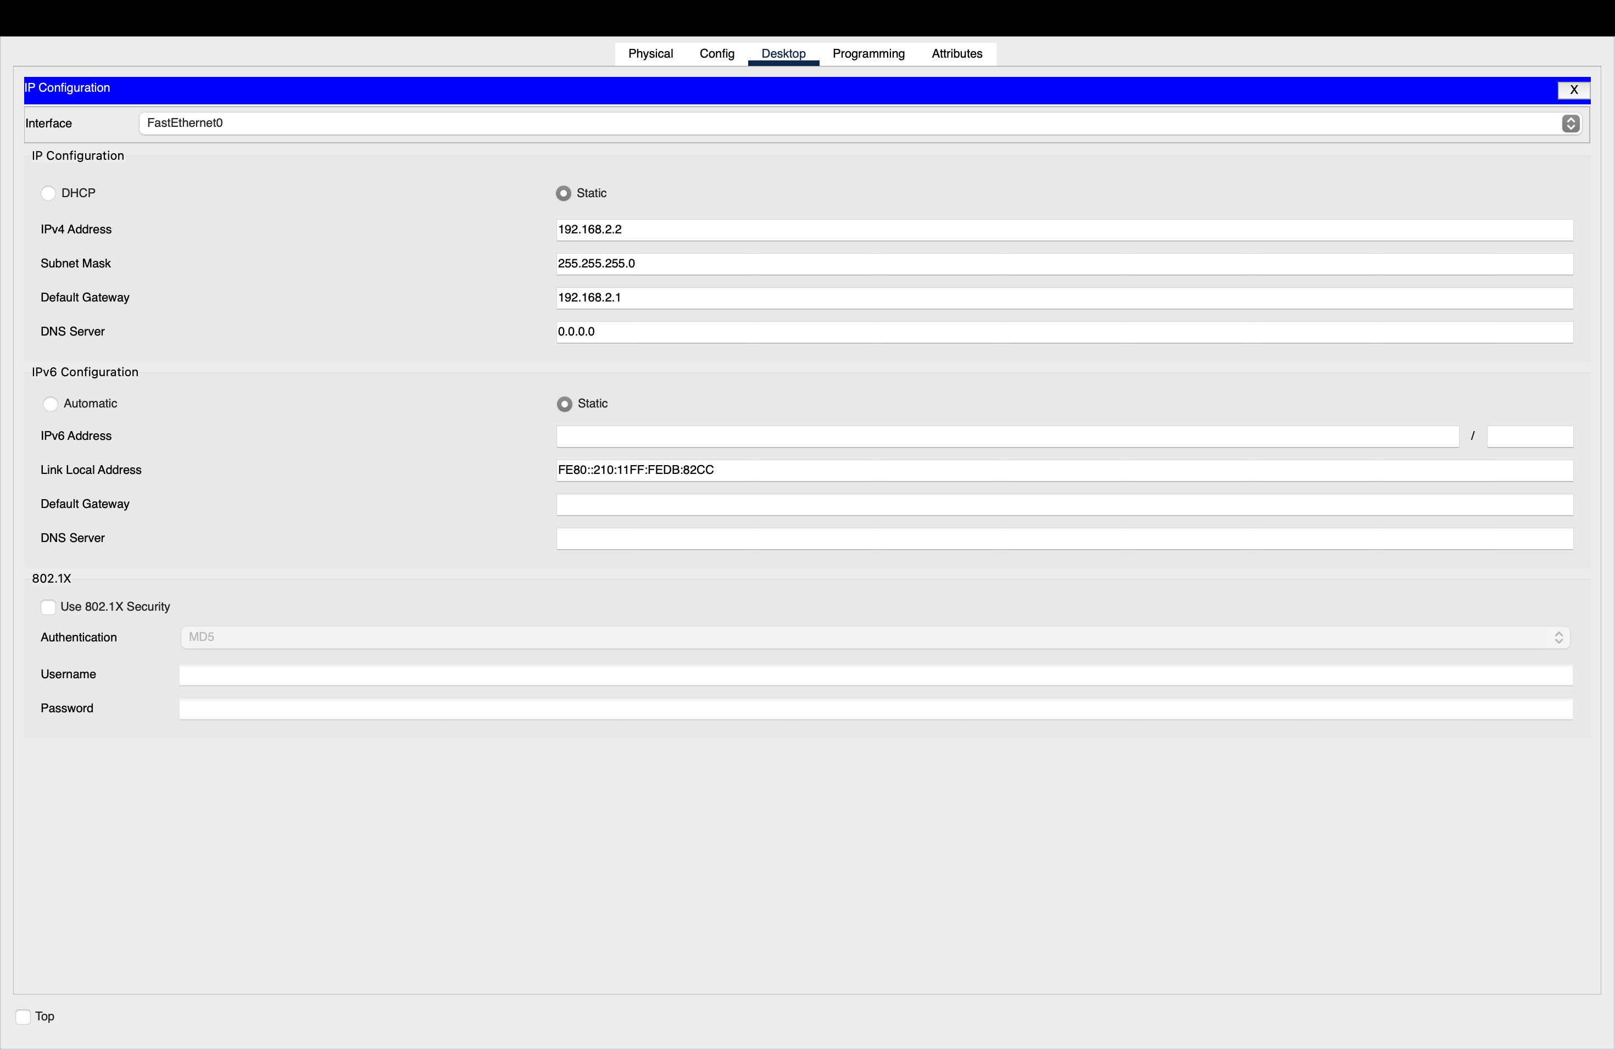
Implementation-3:

Figure 3: IP Address Configuration of PC1

Explanation:
The figure shows the IPv4 configuration of PC1 in Cisco Packet Tracer. PC1 is assigned the static IP address 192.168.2.2 with the subnet mask 255.255.255.0. The default gateway is configured as 192.168.2.1, which is the router interface connected to PC1. This configuration allows PC1 to communicate with the router and with devices on other networks.
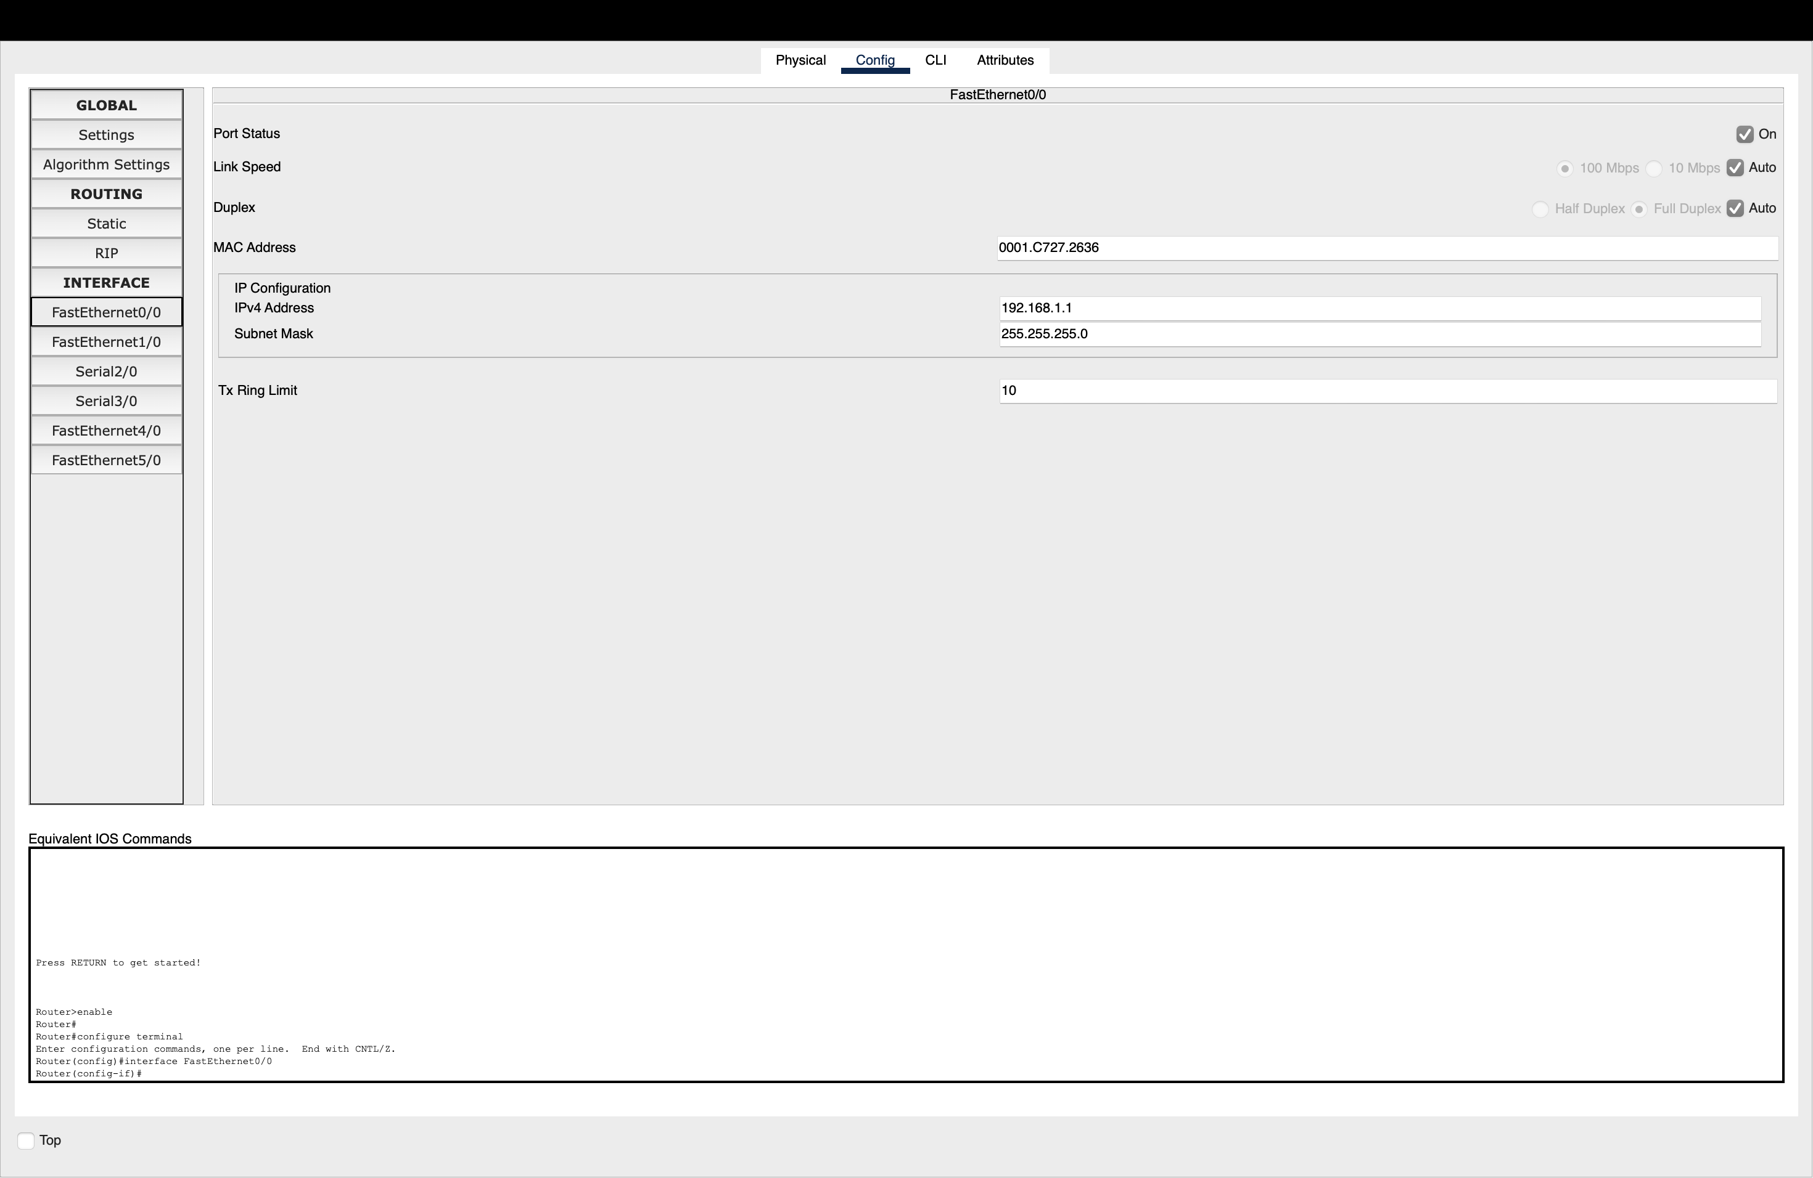
Implementation-4:
Figure 4: Router Interface Configuration for PC0 Network
Explanation:
The figure shows the configuration of FastEthernet0/0 on Router0. The interface is enabled and assigned the IP address 192.168.1.1 with subnet mask 255.255.255.0. This interface acts as the default gateway for PC0 (192.168.1.2) and connects PC0's network to the router.
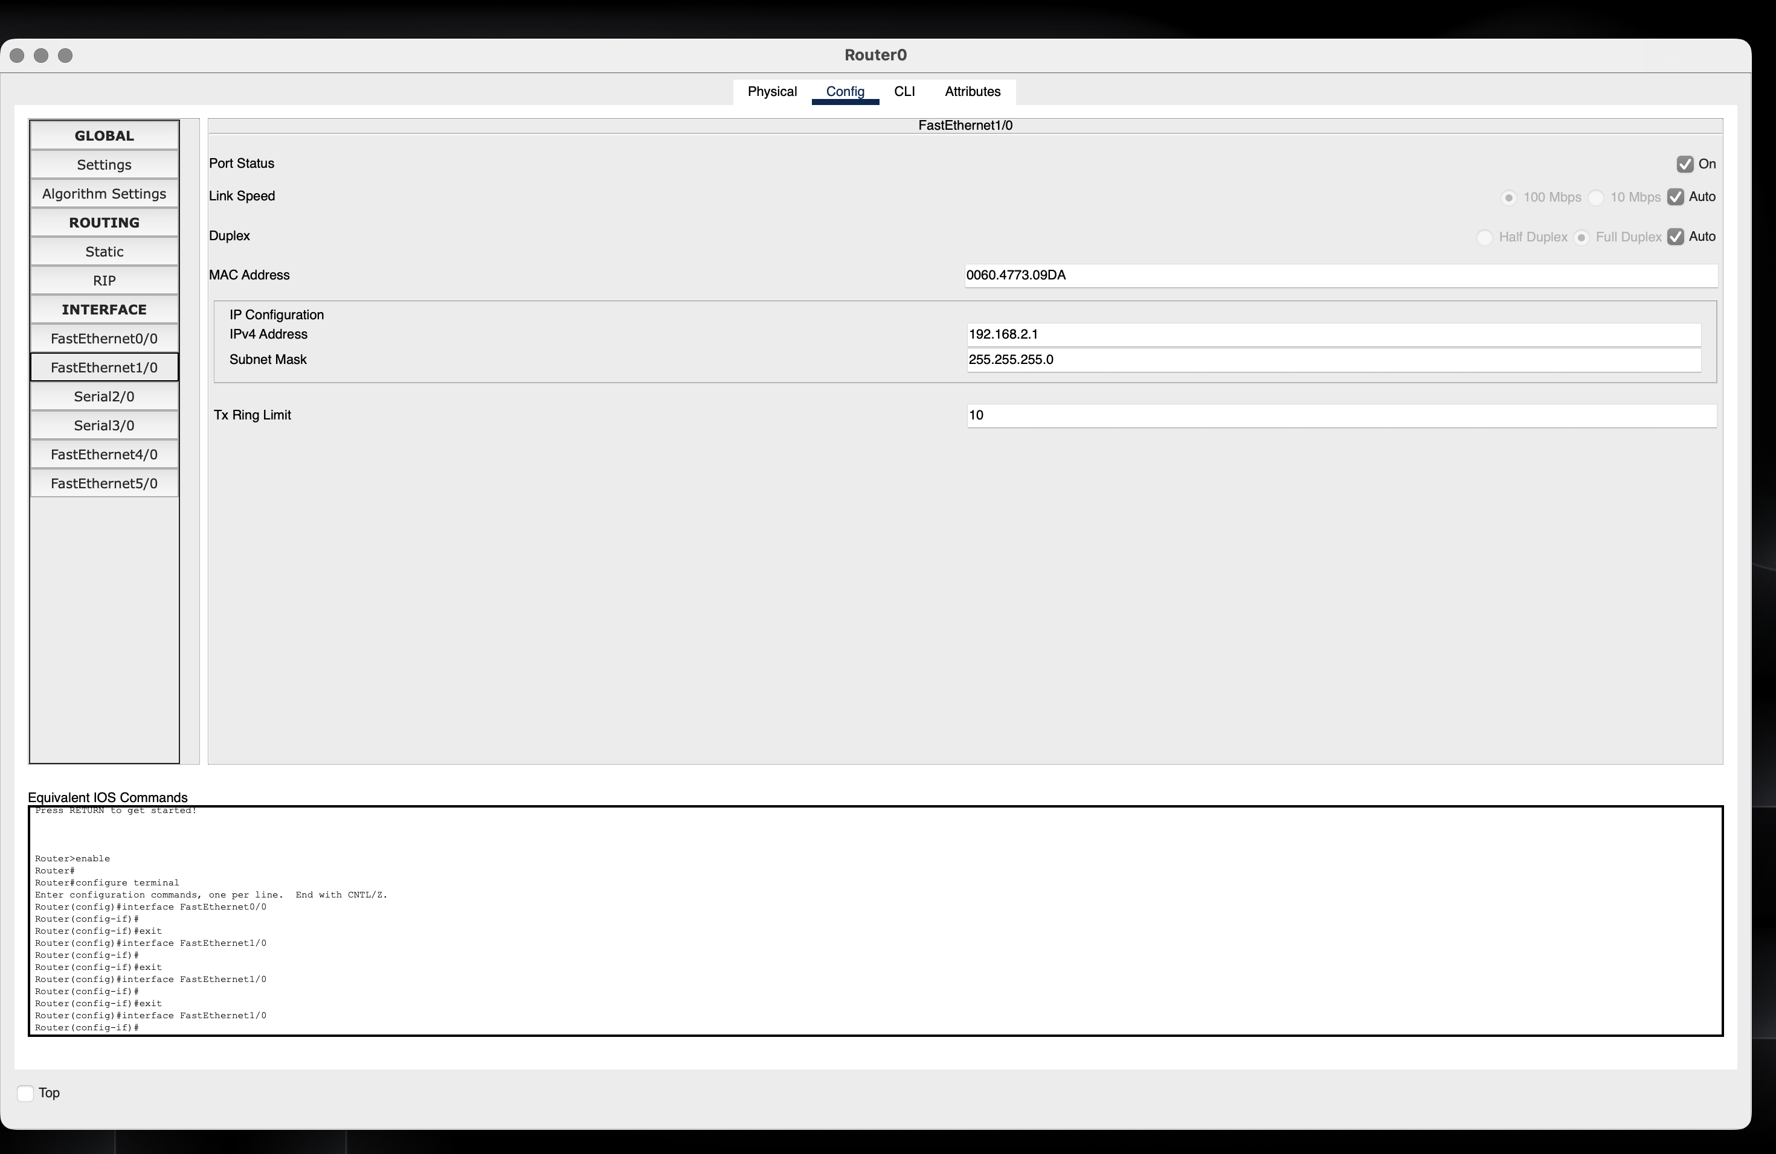
Implementation-5:

Fig5:RouterInterface Configuration for PC1 Network

Explanation:
The figure shows the configuration of FastEthernet1/0 on Router0. The interface is enabled and assigned the IP address 192.168.2.1 with subnet mask 255.255.255.0. This interface acts as the default gateway for PC1 (192.168.2.2) and connects PC1's network to the router.

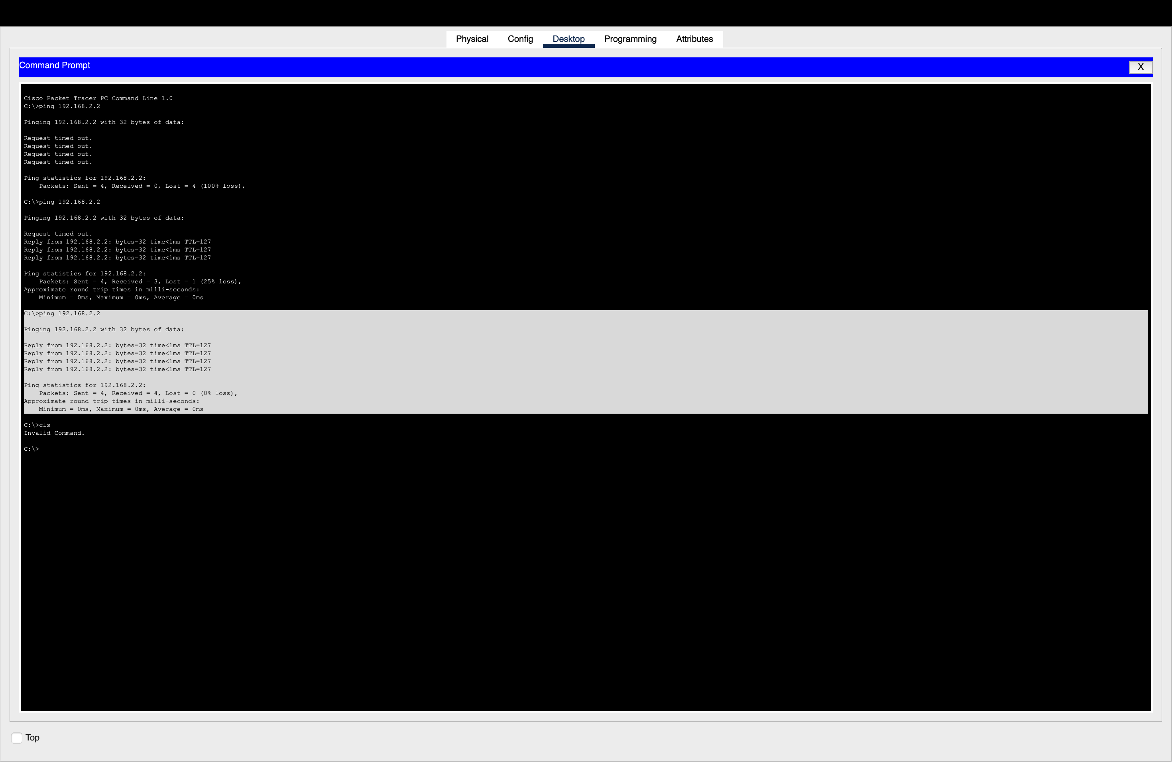
Implementation-6:

Figure 6: Successful Ping Connectivity Between PC0 and PC1
Device | Interface | IP Address | Subnet Mask | Default Gateway
PC0 | FastEthernet0 | 192.168.1.2 | 255.255.255.0 | 192.168.1.1
Router0 | FastEthernet0/0 | 192.168.1.1 | 255.255.255.0 | —
Router0 | FastEthernet1/0 | 192.168.2.1 | 255.255.255.0 | —
PC1 | FastEthernet0 | 192.168.2.2 | 255.255.255.0 | 192.168.2.1
Explanation:
The ping 192.168.2.2 command was successfully executed from PC0 to PC1 through the router. All four ICMP packets received replies, resulting in 0% packet loss. This confirms that the IP configuration and routing between the two PCs are working correctly.

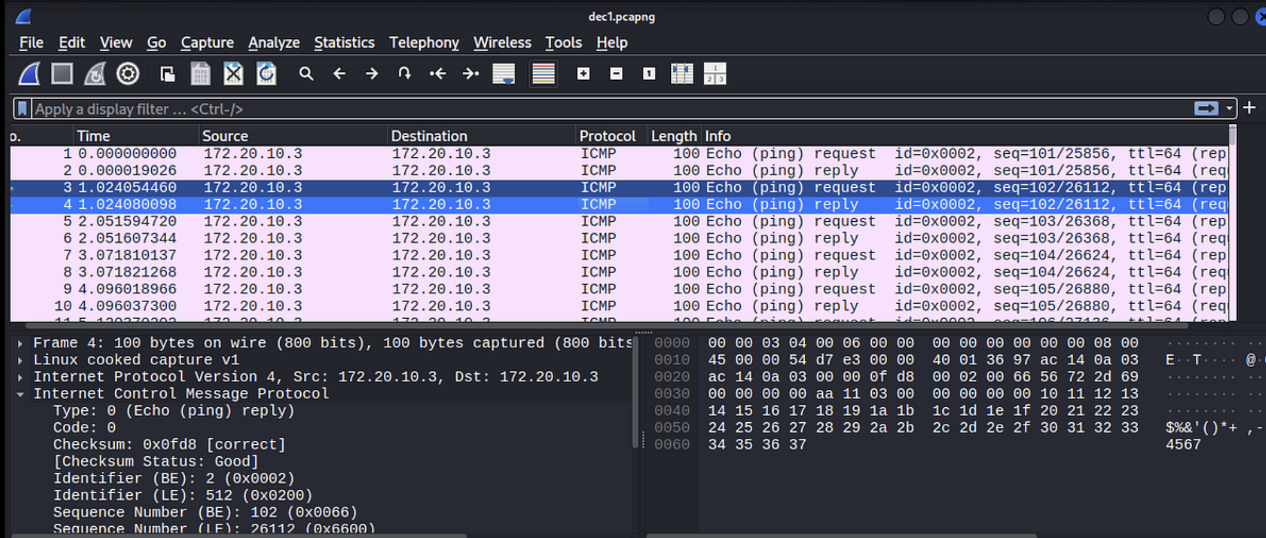
Implementation-7:
Figure 7: Wireshark Capture Showing ICMP Echo Request and Echo Reply Packets

ICMP Field | Echo Request | Echo Reply | Explanation
Type | 8 | 0 | Type 8 represents Echo Request and Type 0 represents Echo Reply.
Code | 0 | 0 | Code 0 indicates a normal ICMP echo message.
Identifier | Same value | Same value | Identifies the ping process and matches the request with its reply.
Sequence Number | 0, 1, 2, 3... | Same number | Identifies the individual ping request and its corresponding reply.

ICMP in Network Troubleshooting and Connectivity Verification:
ICMP helps network administrators check whether devices are reachable and communicating correctly. The ping command uses ICMP Echo Request and Echo Reply messages to verify connectivity between two devices. It also provides information about packet loss and Round Trip Time (RTT), which helps identify network delays or failures. ICMP error messages can indicate problems such as unreachable hosts or networks. Therefore, ICMP is useful for detecting connectivity issues, measuring response time, and troubleshooting network communication.

RUBRICS FOR CALCULATION

Criteria | Weightag e | Level 4 – Exemplary | Level 3 – Proficient | Level 2 – Developing | Level 1 – Beginning
Understandin g of Concepts | 25 | Demonstrates thorough understanding and effectively integrates multiple  concepts/technologi es | Good understanding with proper integration of most concepts | Basic understanding  ; limited or partial integration | Poor understanding  ; unable to integrate concepts
Experimental Design | 30 | Well-planned, systematic implementation with optimal solution | Correct implementati on with minor issues | Basic implementati on with errors or inefficiencies | Incorrect or incomplete implementati on
Use of Tools | 20 | Effective and advanced use of tools/technologies with proper configuration | Appropriate use of tools with correct execution | Limited or inconsistent use of tools | Incorrect or minimal use of tools
Analysis of Results | 15 | Insightful analysis with accurate interpretation and validation of results | Good analysis with reasonable interpretation | Basic analysis with limited insights | Poor or incorrect analysis of results
Documentati on | 10 | Clear, well-structured documentation with diagrams, code, and results | Organized documentatio n with necessary details | Basic documentatio n with missing details | Poor or incomplete documentatio n

